# **📘 Day 2 – Command Types in PostgreSQL 🚀**

### **Understanding the Different Commands for Database Operations 🐘**

### 5 types Commands in SQL

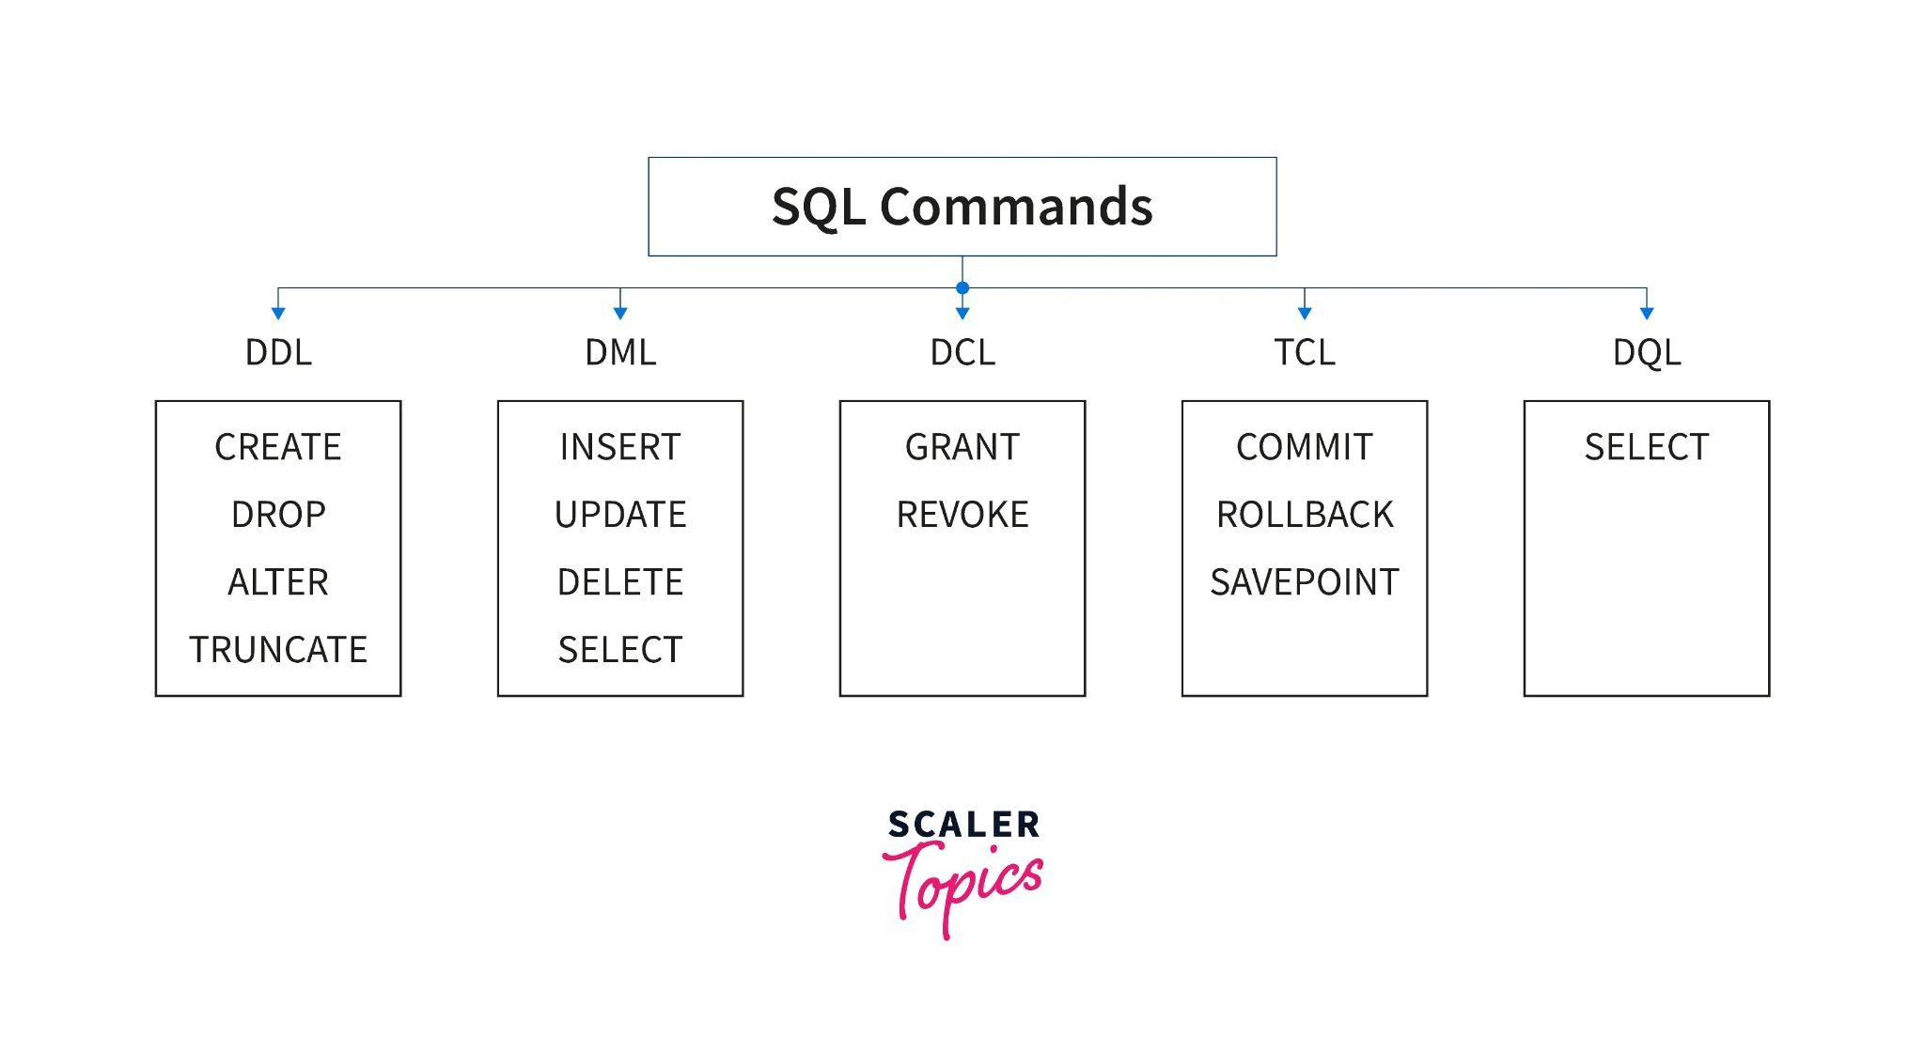

### Data Definition Language (DDL)

DDL commands define, modify, and manage database objects like tables, schemas, and indexes

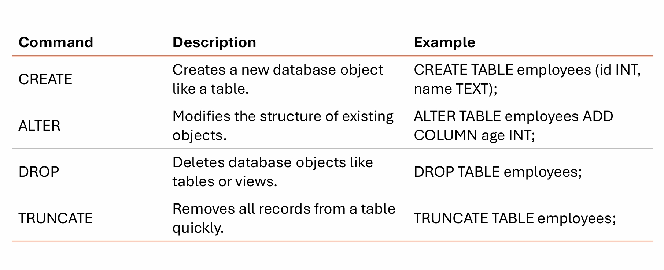

### Data Manipulation Language (DML)

DML commands handle data within tables, such as inserting, updating, or deleting rows.

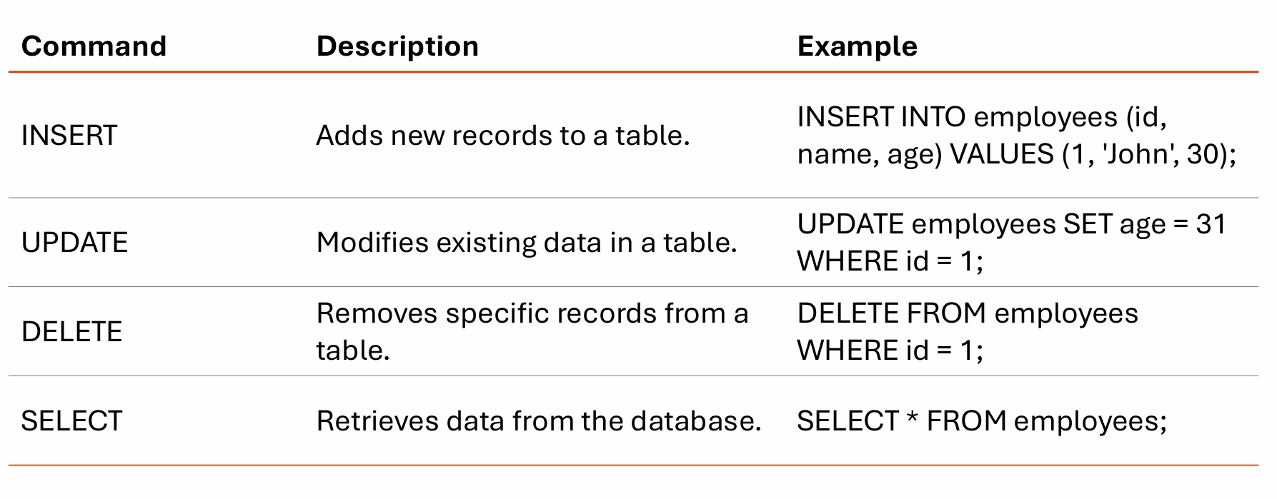

### Transaction Control Language (TCL)

TCL commands manage database transactions, ensuring data consistency and integrity.

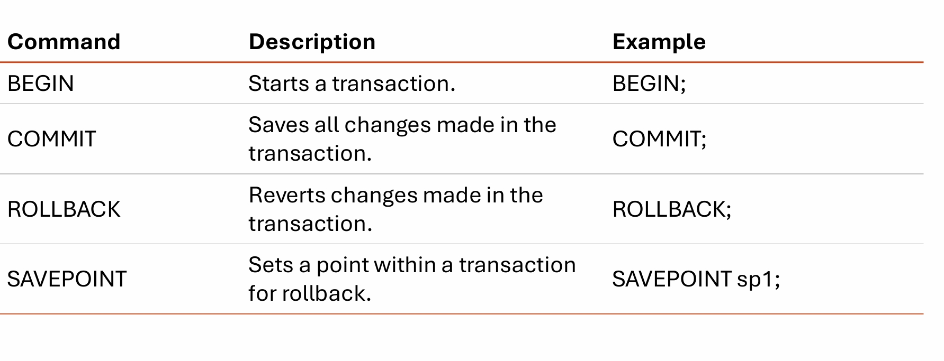

### Data Control Language (DCL)

DCL commands control user access and permissions to the database objects.

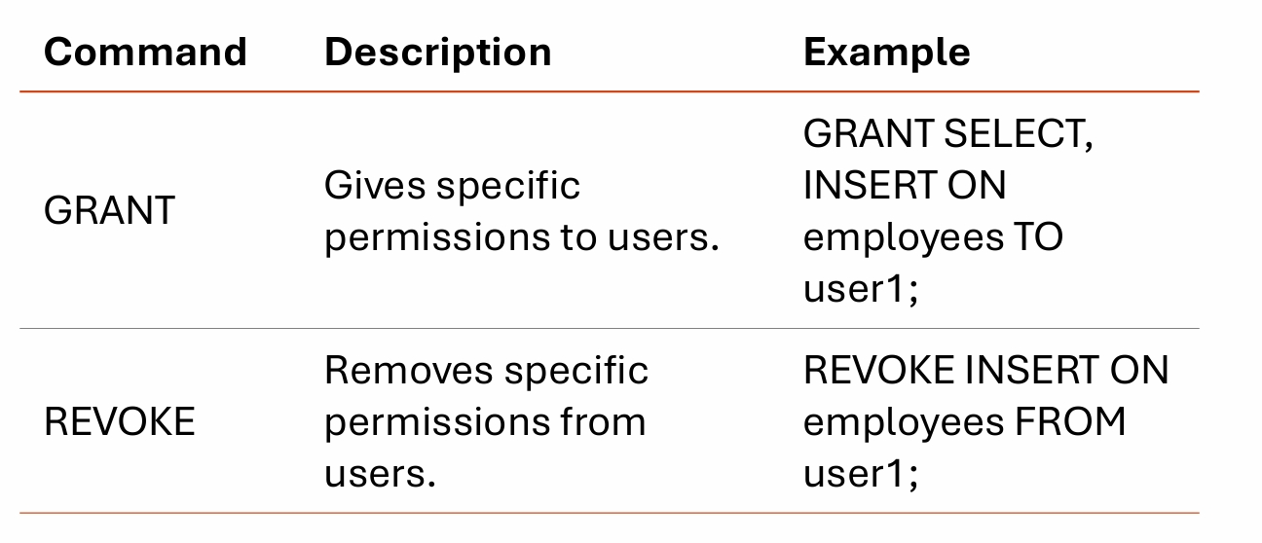

### Data Query Language (DQL)

DQL focuses on querying data from the database. Though technically part of DML, it’s often separated to emphasize its importance

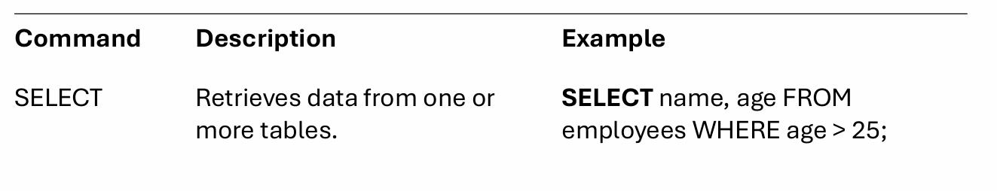

🔍Note

Always use COMMIT and ROLLBACK carefully to avoid unintended changes, especially in critical databases. Practice using SELECT frequently to understand your data before making changes with DML commands.

### Difference Between SQL and NoSQL Databases

